**PROJECT DOCUMENTATION**

**Submitted by:**

|  |
| --- |
| Shambhavi Mewar |
| Supriya Chaudhari |
| Sneha Bhargav |
| Rutik Wagh |
| Zaki Akhtar |
| Surbhi Gusain |
| Nandini Desai |
| Raghav |

Date of Submission:

15-09-2023



**Online Event Planner**



**Acknowledgement**

We would like to extend our heartfelt gratitude to all those who contributed to the successful execution of our Online Event Planner Project. This endeavor would not have been possible without the dedication, hard work, and support of many individuals and organizations.

First and foremost, we would like to express our appreciation to our project team for their unwavering commitment and tireless efforts throughout the project's lifecycle. Your creativity, teamwork, and problem-solving skills were instrumental in bringing this project to fruition.

This project's success is a testament to the collective effort, vision, and determination of all those involved. We are proud of what we have achieved and look forward to continued growth and innovation in the field of event planning.

**Table of Contents**

Introduction

Project Scope

Functional Requirements

Non-Functional Requirements Use Cases

Interface Description (UI) Database Description

Implementation Description

Conclusion



**Introduction**

In a world marked by busy schedules, diverse preferences, and evolving event trends, the need for a comprehensive and user-friendly solution for event planning has never been more pronounced. The "Online Event Planner Project" emerges as a response to this demand, offering a dynamic and innovative platform to simplify and elevate the art of event management.

The Online Event Planner Project is poised to transform the way individuals and organizations plan, organize, and execute events. By harnessing the power of technology and intuitive design, our platform endeavors to provide users with a seamless and efficient experience, regardless of the scale or nature of their events. From weddings and corporate conferences to birthday parties and charity galas, this project promises to be the go-to solution for all event planning needs.

**Project Scope**

The project scope for an online event planner website typically includes the following elements:

1. Project Objectives and Goals:

- Define the primary purpose of the website (e.g., event planning and coordination).

- Outline specific goals, such as increasing event bookings or user engagement.

2. User Requirements:

- Identify the target audience (e.g., individuals, businesses, event planners).

- List user needs, such as event discovery, planning tools, and online booking.

3. Features and Functionality:

- Event Listings: Display a variety of events with filters and search options.

- User Registration and Profiles: Allow users to create and manage accounts.

- Event Planning Tools: Provide features like budget calculators, seating charts, etc.

- Booking and Payment: Enable users to book events and make payments online.

- Reviews and Ratings: Allow users to rate and review events and vendors.

- Vendor Listings: Include a directory of event service providers.

- Messaging and Notifications: Facilitate communication between users and vendors.

- Content Management: Admin panel for managing events, users, and content.

- Mobile Responsiveness: Ensure the website is accessible on various devices.

4. Design and User Interface:

- Define the website's overall look and feel.

- Create wireframes and mockups for key pages.

- Ensure a user-friendly and intuitive interface.

Technology Stack:

- Specify the technologies and programming languages to be used (e.g., HTML, CSS, JavaScript, PHP, or a CMS like WordPress).

6. Database and Data Management:

- Plan the database structure for storing user data, event information, and bookings.

- Consider data security and privacy measures.

7. SEO and Marketing:

- Implement SEO best practices to improve website visibility.

- Plan for digital marketing strategies (e.g., social media integration).

8. Testing and Quality Assurance:

- Develop a testing strategy to identify and resolve bugs and issues.

- Conduct usability testing to ensure a smooth user experience.

9. Launch Plan:

- Define the launch date and promotional strategies.

- Consider a soft launch to gather user feedback before a full release.

10. Maintenance and Support:

- Outline plans for ongoing maintenance, updates, and customer support.

11. Budget and Timeline:

- Estimate the project cost and allocate resources.

- Create a timeline with milestones and deadlines.

12. Legal and Compliance:

- Ensure compliance with data protection laws (e.g., GDPR).

- Address any necessary legal agreements, such as terms of service and privacy policies.

13. Documentation:

- Prepare documentation for code, design, and user guides.

14. Project Team:

- Identify team members and their roles (e.g., developers, designers, testers).

15. Risk Assessment:

- Identify potential risks and mitigation strategies.

16. Feedback and Iteration:

- Plan for collecting user feedback and making improvements after launch.

**Functional Requirements**

Functional requirements for an online event planner website specify the specific functions and capabilities the website must have to meet user needs and achieve its goals. Here are some key functional requirements for such a website:

1. User Registration and Profiles:

- Users should be able to create accounts with personal information.

- Users can log in and manage their profiles, including contact details and preferences.

2. Event Listings:

- Provide a searchable and filterable list of events.

- Display event details, including date, time, location, description, and images.

3. Event Creation and Management:

- Event organizers should be able to create and manage their events.

- Include options for adding event details, pricing, and availability.

4. Booking and Reservation:

- Users should be able to book events they are interested in attending.

- Implement a booking system that allows users to select event options and make payments securely.

5. Event Planning Tools:

- Offer tools like budget calculators, guest list managers, and seating chart generators.

- Allow users to save and edit their event plans.

6. Vendor Listings and Management:

- Include a directory of event service providers (caterers, photographers, etc.).

- Vendors should be able to create and manage their profiles.

7. Messaging and Communication:

- Enable users to communicate with event organizers and vendors through messaging.

- Provide notifications for booking confirmations, updates, and messages.

8. Reviews and Ratings:

- Allow users to rate and review events they've attended.

- Display average ratings and reviews for events and vendors.

9. Search and Recommendation:

- Implement a recommendation system that suggests events based on user preferences and past behavior.

- Enable users to save and bookmark events for later.

10. User Notifications:

- Send email or push notifications for upcoming events, promotions, or messages.

- Allow users to manage their notification preferences.

11. Content Management:

- Admins should have the ability to manage and update event listings, user accounts, and vendor profiles.

- Implement a content management system (CMS) for easy updates.

12. Security and Privacy:

- Ensure secure handling of user data and payment information.

- Implement user authentication and authorization mechanisms.

13. Mobile Responsiveness:

- Ensure the website is accessible and functional on various devices, including smartphones and tablets.

14. Feedback and Reporting:

- Allow users to report issues or provide feedback.

- Provide analytics and reporting tools for event organizers and administrators.

15. SEO-Friendly Features:

- Implement SEO best practices for event and vendor listings.

- Allow event organizers to optimize their event descriptions for search engines.

16. Integration with Payment Gateways:

- Support various payment methods (credit cards, PayPal, etc.) securely.

- Ensure smooth payment processing for both users and event organizers.

17. Social Media Integration:

- Allow users to share events on social media platforms.

- Enable social media login options for user registration.

18. Localization and Internationalization:

- Support multiple languages and currencies if targeting a global audience.

- Allow users to set their preferred language and currency.

19. Accessibility:

- Ensure the website is accessible to individuals with disabilities by following accessibility standards (e.g., WCAG).

20. Backup and Data Recovery:

- Regularly back up user and event data to prevent data loss.

- Have a data recovery plan in case of unforeseen issues.



**Non-Functional Requirements**

1. Performance:

- Response Time: Specify the maximum acceptable response times for actions like event listing loading, booking, and search queries.

- Scalability: Define how the system should scale to handle increased user traffic and event listings.

- Concurrency: Specify the maximum number of simultaneous users the system should support without performance degradation.

2. Reliability:

- Availability: Define the acceptable uptime percentage (e.g., 99.9%) for the website.

- Fault Tolerance: Specify how the system should handle and recover from unexpected failures, such as server crashes or database errors.

- Data Integrity: Ensure that user data, event information, and payments are stored and transmitted securely to maintain data integrity.

3. Security:

- Authentication and Authorization: Define authentication methods (e.g., username/password, two-factor authentication) and access control rules for user and admin accounts.

- Data Encryption: Specify the use of encryption protocols (e.g., SSL/TLS) for securing data in transit.

- Protection Against SQL Injection and Cross-Site Scripting (XSS): Implement security measures to prevent common web vulnerabilities.

- User Privacy: Ensure compliance with data protection regulations (e.g., GDPR) regarding user data collection and storage.

4. Scalability and Capacity:

- Load Testing: Define performance benchmarks and conduct load testing to ensure the system can handle expected peak loads.

- Resource Utilization: Specify resource usage limits (e.g., CPU, memory, bandwidth) to optimize server and hosting costs.

5. Usability and Accessibility:

- User Interface Consistency: Ensure a consistent and intuitive user interface design throughout the website.

- Accessibility Compliance: Adhere to accessibility standards (e.g., WCAG) to make the site usable by individuals with disabilities.

6. Compatibility:

- Cross-Browser Compatibility: Ensure the website works seamlessly on popular web browsers (e.g., Chrome, Firefox, Safari, Edge).

- Mobile Responsiveness: Confirm that the website is fully functional on various mobile devices and screen sizes.

7. Maintainability and Upgradability:

- Code Documentation: Require thorough documentation of codebase for easy maintenance by developers.

- Modularity: Design the system with a modular architecture to facilitate future updates and enhancements.

8. Compliance and Legal Requirements:

- Regulatory Compliance: Ensure compliance with relevant laws and regulations, such as copyright and intellectual property laws.

- Terms of Service and Privacy Policy: Create clear and legally sound terms of service and privacy policies.

9. Backup and Recovery:

- Data Backup: Define a regular backup schedule for user data, event information, and system configurations.

- Disaster Recovery Plan: Establish a plan for recovering the system and data in case of catastrophic events or data breaches.

10. Logging and Monitoring:

- Logging: Implement logging mechanisms to track system events, user activities, and errors.

- Monitoring: Set up continuous monitoring to detect and address performance issues and security threats.

**Database View**

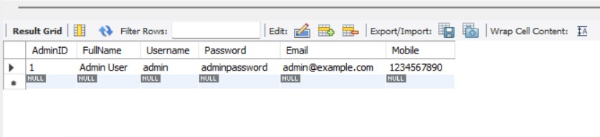

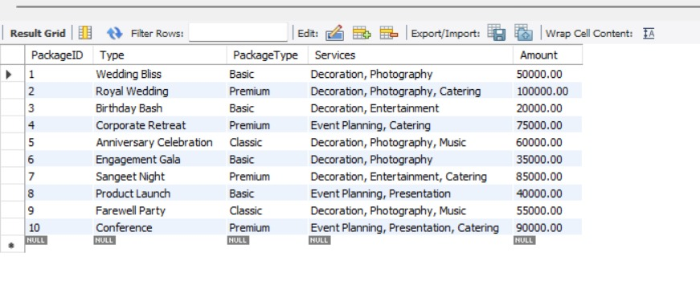

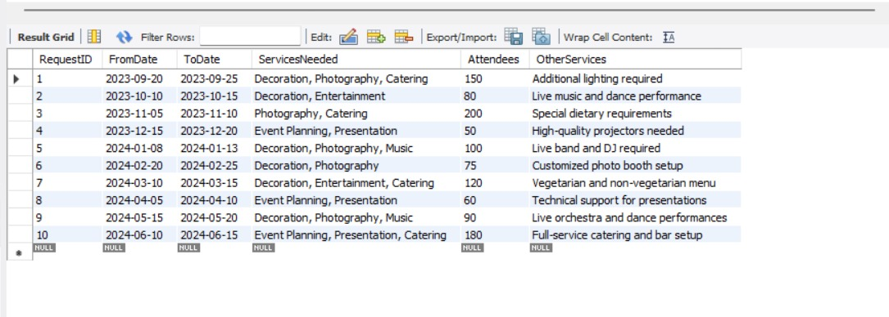

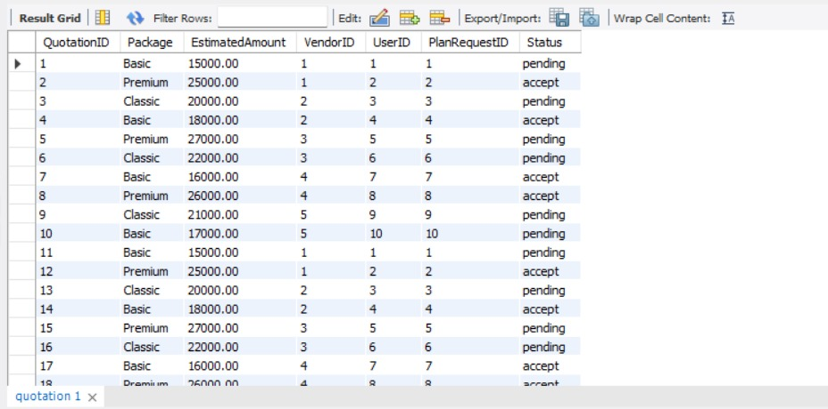

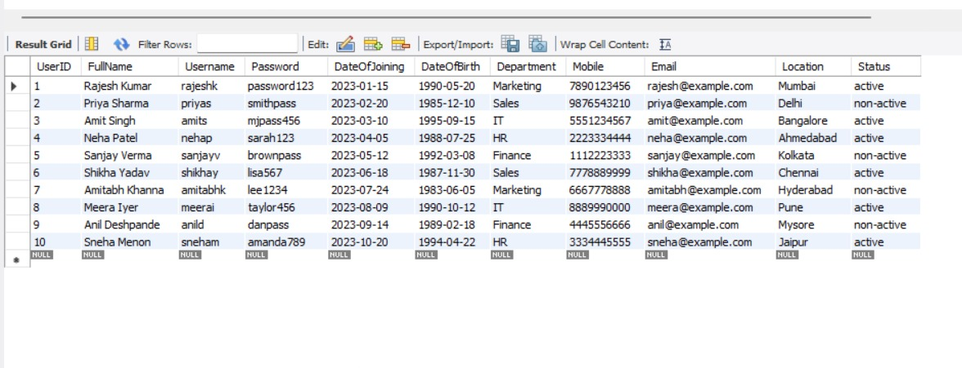

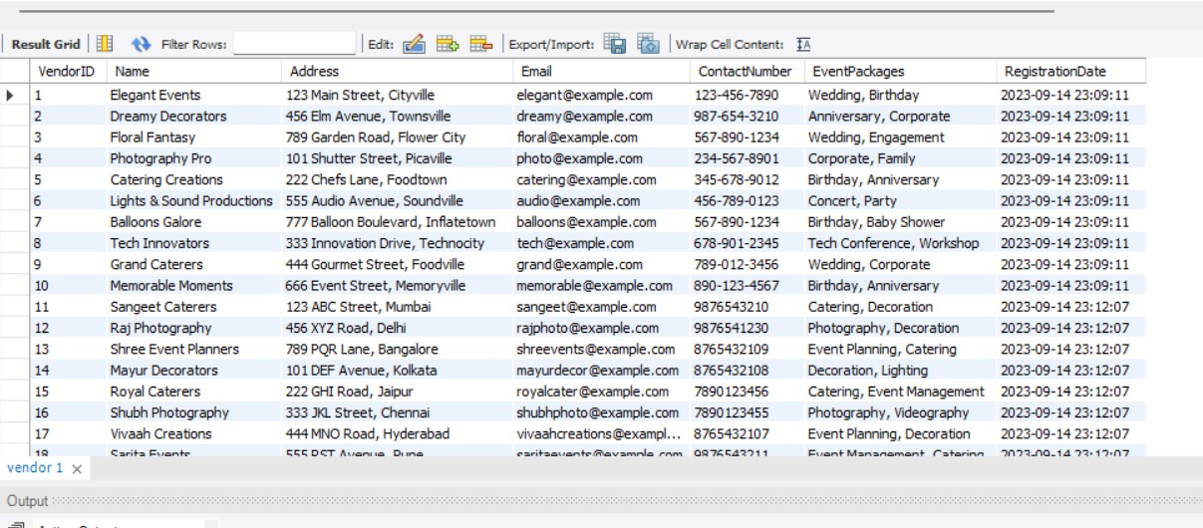



**Use Cases**

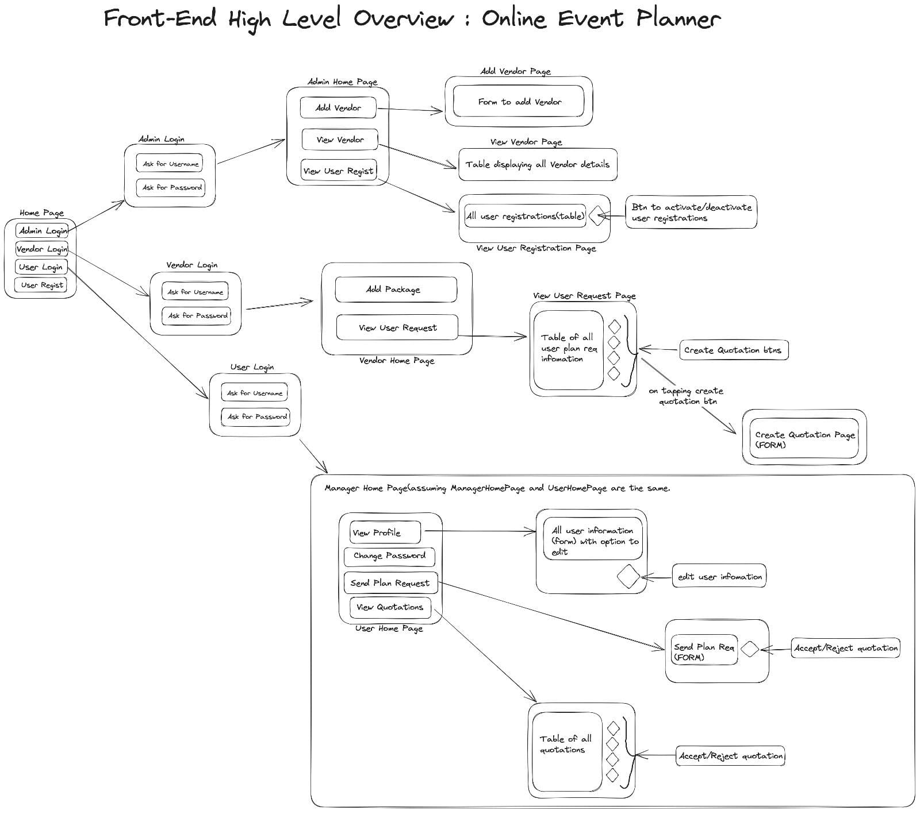

**Interface Description (UI)**

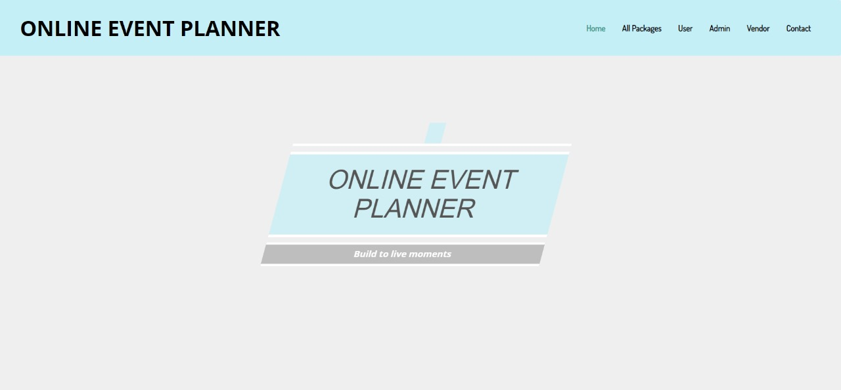Fig 1 : Home Page

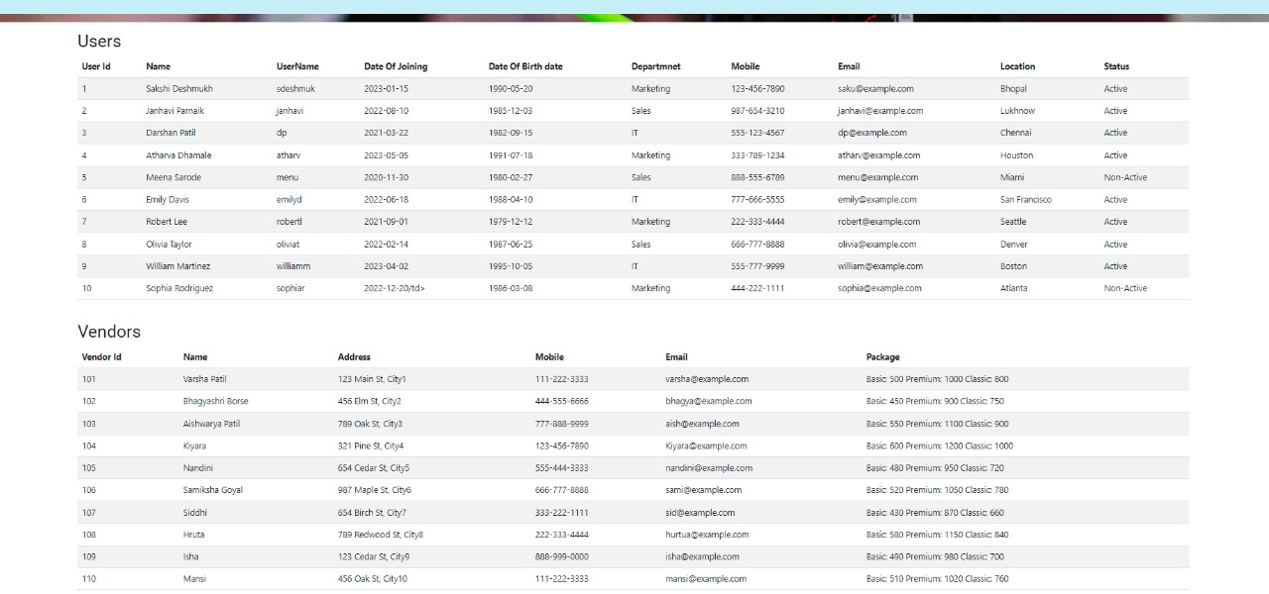

Fig 2 : Admin Page

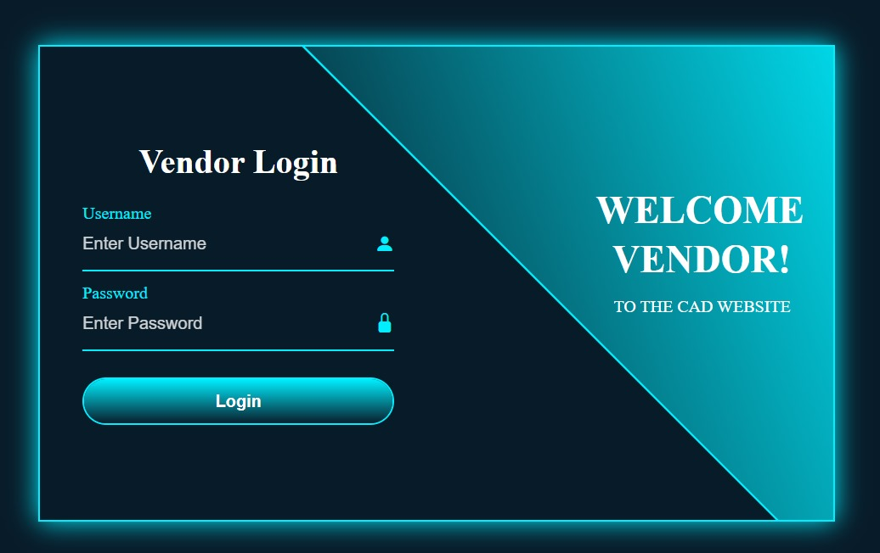

Fig 3 : Vendor Login Page

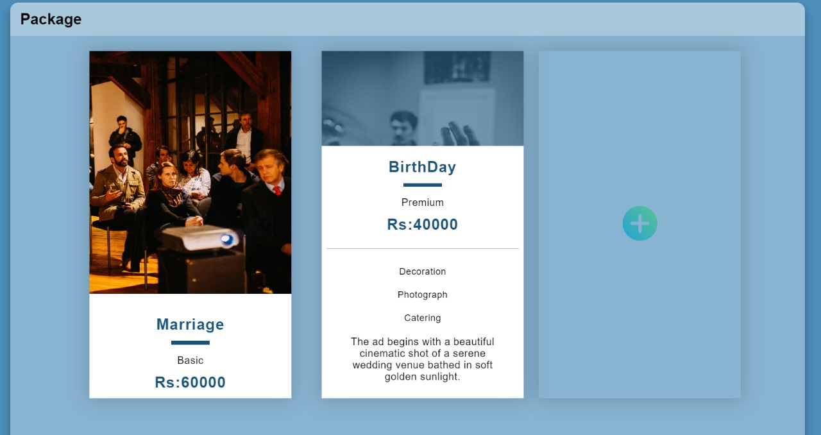

Fig 4 : All Packages Page

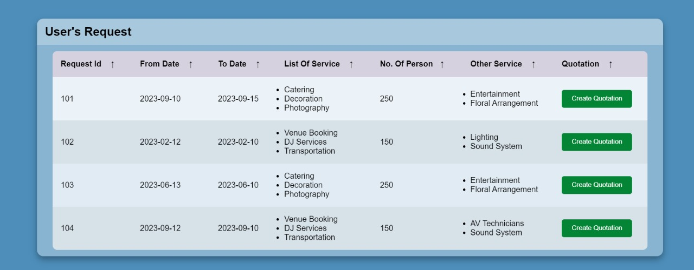

Fig 5 : Quotation Page

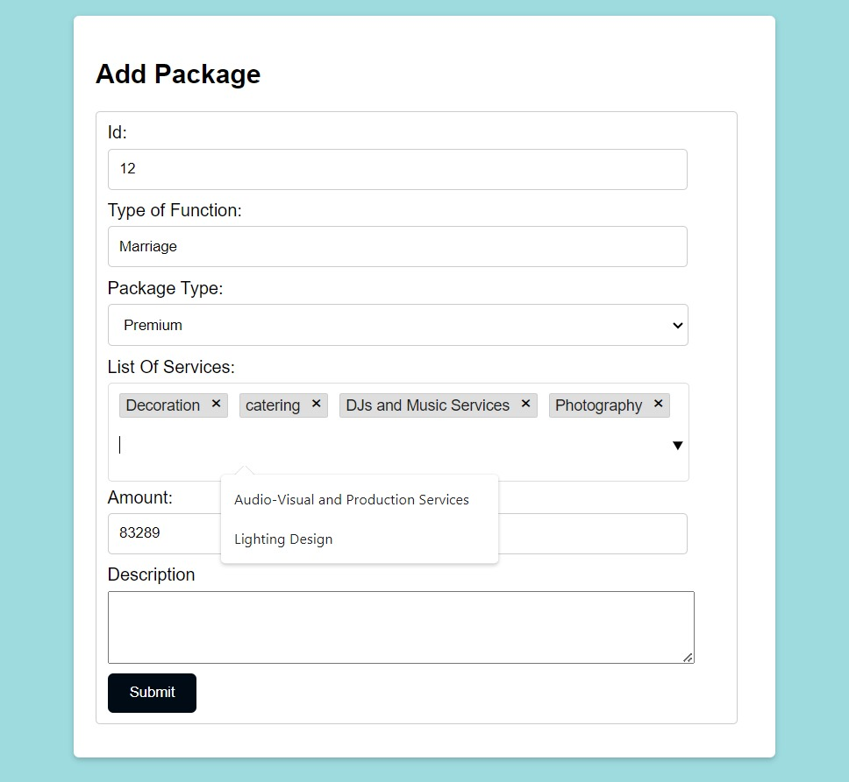 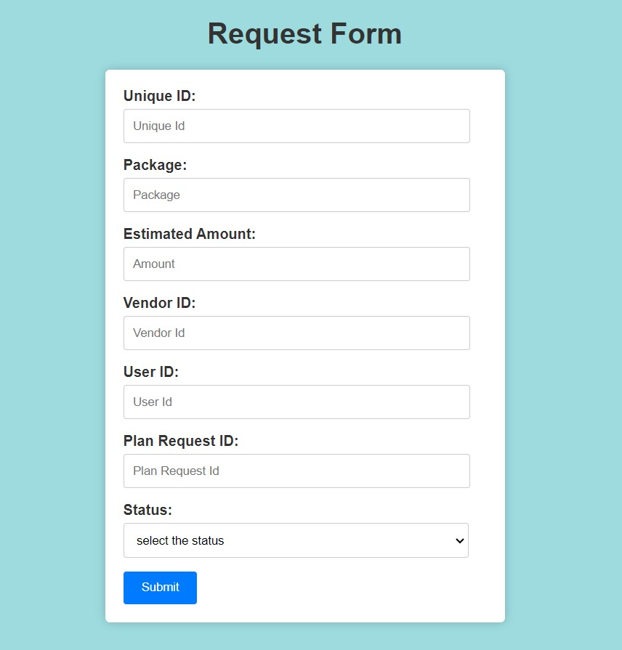

**Conclusion**

In conclusion, developing an online event planner website is a multifaceted undertaking that requires careful planning and execution. The success of such a website hinges on a comprehensive understanding of both functional and non-functional requirements.

Functionally, the website must offer a seamless user experience by providing features like event listings, event planning tools, vendor management, and secure booking and payment systems. It should also prioritize user engagement through features like reviews, recommendations, and messaging.

Non-functionally, the website needs to meet high standards of performance, reliability, and security. This includes ensuring fast response times, high availability, robust data security, and adherence to legal and privacy regulations. Usability, accessibility, and compatibility are also vital for reaching a broad and diverse user base.

Ultimately, a well-executed online event planner website can empower users to discover, plan, and book events with ease, while also enabling event organizers and vendors to connect with their audience. Success in this endeavor requires a dedicated team, a solid technology stack, and ongoing maintenance and improvement efforts to meet evolving user needs and expectations. By addressing these aspects comprehensively, an online event planner website can thrive in the competitive digital landscape and provide value to both event-goers and event organizers.